Partner Request for the project

Action 5.1

“Volunteering, to make better”

Volunteering is not only important part of democracy building and sustainability in every country, but also it brings fair share to the global economy. Each country has its own voluntary work regulations, understanding and support system. But there is also common European level where we share ideas and beliefs. Even though there are many opportunities to join voluntary activities, this area is facing different problems and obstacles for the ones who want to participate. Also potential of voluntary work has not been acknowledged in full.
Experiences of volunteering in every country are different. It is useful to share opinions and practicalities in order to identify best experiences in promoting and supporting volunteerism.

Main objective of the project is to bring together youth experts, youth workers and volunteers in order to raise awareness about voluntary work, who and how can become a volunteer. Emphasis will be put on explaining principles of voluntary work and what can be done to dismiss obstacles that are met nowadays.
As a result Youth Declaration of Volunteering for youth NGO’s will be developed to create an enabling and facilitating environment for volunteering.

!You can find a detailed outline and a draft program of the project
on the next pages of this call!

Practical Information
Dates
The project will last three days. Osmangazi Municipality will welcome all participants on Monday, June 13th 2011 and the departure is foreseen on Friday, June 17th. In short:
13 June 2011 Arrival date
14-15-16 June 2011 Project days
17 June 2011 Departure
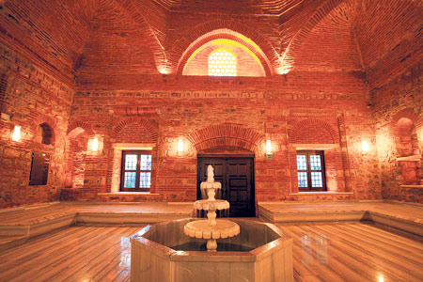

Location / Venue
The project takes place in Osmangazi Municipality, the central district of Bursa in the North-West of Turkey. Bursa is a 2 million city situated near the Sea of Marmara at a three hours bus trip from Istanbul and five hours from Izmir. Since it lies at the foot of Mt. Uludağ (2,543 m) Bursa is well-known for its winter sports such as skiing, and its national park of rich flora and fauna!

The venue will be Bursa’s historical Ördekli Hamamı, a Turkish bath that was neglected for around 100 years before Osmangazi Municipality decided to rescue it. Little by little this “broken down hamam”, whose roots go back to 1400, was transformed into a cultural center for the city. These days, this spot has truly become an important cultural site for city residents.

Participants
We invite ten to fifteen organizations (delegations) from different countries all over Europe. Since all sessions will be held in English we expect at least a basic English knowledge of the participants. Each delegation exists of four participants, and should have the following composition:

1 youth expert, youth leader
1ex or present EVS volunteers
2 youngsters that are active local volunteers

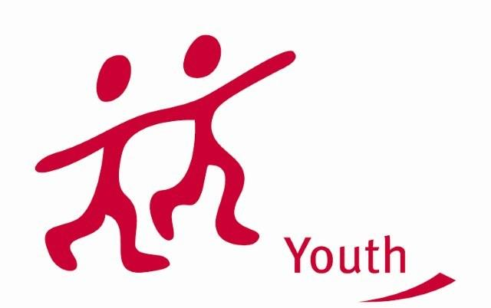
Financial conditions

The project will be mostly funded by the Youth in Action program of the European Commission. Therefore, food and lodging will be fully covered for all participants. Also exceptional costs such as actual costs covering visa, visa-related costs and vaccination costs, as well as costs related to participants with special needs will be covered. 70% of the travel costs are reimbursed (according to the Youth in Action standards), therefore the participants are only obliged to cover 30% of their travel cost themselves.

Deadline

We strive to meet the 1 February 2011 deadline for the project to be sent to the Turkish National Agency and would be very happy ıf we could include your comments and suggestions.

Therefore we would be very pleased to receive your expression of interest and your signed Part III form before january 15th 2011, both digitally and via regular mail or fax.

Contact Detaıls

Contact Person: Ms. Elina ZVIGURE
Mr. Şenol DÜLGER – External Relation Officer
Mr. Ali GÜLBAY – Coordinator

Address: Osmangazi Belediyesi Avrupa Birliği Koordinasyon Merkezi
Santral Garaj Mah. Ulubatli Hasan Blv. No:6
Osmangazi Bursa 16100
TÜRKİYE (TURKEY)

Tel: 00 90 224 2707056
Fax: 00 90 224 2707019

E-mail: elina.zvigure@inbox.lv
eu@osmangazi.bel.tr

Web: EU Coordination Center: www.osmangaziab.org
Osmangazi Municipality: www.osmangazi.bel.tr

Description of the Organisation

Osmangazi Municipality EU Coordination Center

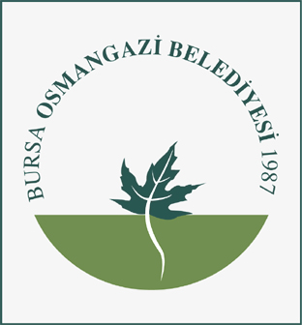
The goal of Osmangazi Municipality in view of this project is mainly to foster youth participation in public life and by extension Local Youth Policy. In general the main objective of the EU Coordination Center is to raise awareness among youngsters about European Union youth projects and policies. Considering democracy not only as a procedure but as an ongoing process that needs to be fed, our most general aim is fostering a larger participation in local life (not only in politics). As a key part of society, youth is a privileged target of all our activities.

Activities

Osmangazi Municipality is a local authority and a metropolitan district of the Bursa Province in Turkey. Our social activities concern many fields such as education, youth activities, sport activities, social services (centre for social rehabilitation and integration of blind people, social services complex, daily care centre for mentally disabled persons) , cultural activities, youth services (youth office and council), women office and council.

Osmangazi Municipality pays also a great attention to European projects and programmes, particularly concerning youth (also European Voluntary Service). Osmangazi Municipality has carried out many projects in this field as the “Youth democracy projects for culture”, a project that deserved to be financed by the Turkish National Agency among many others. All the activities aim at social inclusion and citizen participation with a special attention to all categories with fewer possibilities.

Currently Osmangazi Municipality is taking the lead in a national youth networking project (Action 5.1) about Local Youth Policy: “Structured dialogue on Local Youth Policy”. In a partnership with seven of the biggest municipalities of Turkey, youngsters from all over the country are discussing topical issues and putting forward creative proposals concerning Local Youth Policy in Turkey. With the project “Local Youth Policy – Municipality’s Priority” we want to bring our experience in this field to a higher level, developing a transnational network.

Brief description of the project

Being a part of community

Volunteering is important part of democracy building and sustainability in every country, it has positive effect on community, and it brings economical benefits as well as gives civic contribution. Volunteering is a way of ensuring social participation, empowering, feeling useful and being active for good purpose and every person should be able to take part in this. European countries on some level share common understanding of volunteering. But because of different historical experiences and developments, on national level each country has its own voluntary work regulations, understandings and support systems. Discussing commonalities in an EU context and sharing differences on national levels can help promote civic participation and people-to-people activities and address existing obstacles to voluntary activities, raise awareness of the value and importance of volunteering and contribute to harmonious societal development.

Even though there are many opportunities to join voluntary activities on national and international level, this area is facing different problems and obstacles for the ones who want to participate. Not everyone in Europe is allowed or is able to volunteer.

Also potential of voluntary work has not been acknowledged in full. It is undeniable that while volunteering people acquire skills and competences - extending their networks and social capital and improving their self esteem thus enhancing their employability - more can be done to unleash the full potential of volunteer opportunities and in promoting the recognition of these skills and the positive impact of volunteering.

Objectives and priorities of the project

We all live in one shared Europe and at the same time we have our own national experiences. Experiences of volunteering in every country are different. It is useful to share opinions and practicalities in order to identify best experiences in promoting and supporting volunteerism.
On European level European Voluntary Service is one of the most popular and most accessible volunteering options and this volunteering contributes to issues that are of common concern for all participant countries. Because of this main topics of the meeting are:
- Basic principles of voluntary work
- Legal framework and recognition of voluntary work on European and national level
- Voluntary work actors, importance and support system on European and national level
- Values and benefits of volunteer work
- Obstacles of volunteer work
- European Voluntary Service – community building on European level
- Developing recommendations for youth NGOs for volunteering promotion, inclusion and improvement of environment of volunteering.

Main objective of the project is to bring together youth experts, youth workers and volunteers in order to raise awareness about voluntary work, who and how can become a volunteer, what obstacles we face nowadays and how can they be tackled.
As a result Youth Declaration of Volunteering for youth NGO’s will be developed to create an enabling and facilitating environment for volunteering.

Activities
Objectives will be reached through different activities.
Through expert lead discussions of relevant topics, like what is voluntary work, existing legal framework of volunteering, what are rights and obligations of volunteer, comparison of volunteering support systems in every participant country. Through participant discussions, case studies and group work main obstacles of volunteering and ways of how can we overcome these obstacles will be clarified. With contribution of each participant, discussion of social inclusion will be developed and through role-plays and workshops, suggestions of improving level of participation between socially inactive young people will be founded.

Methodology
”The Role of Volunteering” project will be based on the principles and practice of non-formal education taking into account the participants’ needs, motivations and experiences as starting point of the programme. The working methods to be used during the project are: presentations, power brainstorming, group work, round table discussions and role-plays. Contributions from youth workers, experts and volunteers will be used as a tool to ensure a mutual learning environment and the follow up of a valuable Youth Declaration of Volunteering.

The process is based on:

- The main motivation of the participants;
- Participant-centered and experiences of participants;
- Personal responsibility supported by a strong group dimension and a collective approach;
- Enabling participants to apply and transfer what they have learned to their youth work practice.

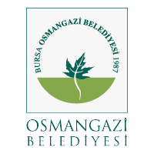
“Volunteering , to Make Better”

Draft Time table
13-17 June 2011, Bursa, Turkey
Time | Day 1, 13th June | Day 2, 14th June | Day 3, 15th June | Day 4, 16th June | Day 5, 17th June
8.00-9.00 | Arrival | Breakfast | Breakfast | Breakfast | Breakfast
9.00 –11.00 | Arrival | Introduction to the theme, timetable and activities of the meeting.  Expert presentation: Concept and understanding of volunteering. | Expert presentation: Actors, importance and support system of voluntary work on European level.  Presentations of participants from each country: Actors, importance and support system of voluntary work on national level. | Expert presentation and discussion with participants: European Voluntary Service – community building on European level: opportunities, issues and problems | Departure
11.00-13.00 |  | Coffee break | Coffee break | Coffee break
11.00-13.00 |  | Expert presentation: Legal framework and recognition of voluntary work on European level.  Expert presentation: Current issues and challenges of volunteering on European level.  Expert presentation: Voluntary work opportunities on European level. | Continuation of participant presentations. | Development of Youth Declaration on Volunteering.  Evaluation of the meeting
13.00-14.30 |  | Lunch | Lunch | Lunch
14.30-16.00 |  | Group work of participants: Basic principles of voluntary work. Benefits of volunteer work, obstacles of volunteer work. | Discussion panel: Issues in volunteering on youth, youth organizations, and youth worker levels. | Free time
16.00-16.30 |  | Coffee break | Coffee break
16.30-17.00  17:15-18:00 |  | Presentation of the results of group work.  City tour | Continuation of the discussion | Free time
18.00-19.30 | Dinner | Dinner | Dinner | Dinner
20.00- | Getting to know each other party | Intercultural evening | Free time | Good bye party

